Voucher Storage and Retrieval System

Parks User Guide

DNR Accounting Office has been using paper and file cabinets to store their vouchers. Due to the reduced use of P-cards, the number of vouchers has increased, which has increased paper storage space requirements.
The purpose of this system is to convert the paper-based system into a web-based system. The newly developed web-based system will allow the field officers to enter the information into the system using a web form and then store the vouchers electronically. This system will also let the accounting staff retrieve the information, edit the information and will also let them download the vouchers depending upon their roles.

Here is the link to login to ‘Voucher Storage and Retrieval System’.
http://www1.gadnr.org/dnr/voucher/app

Login:
Username & password is required to access the application. Username is not case-sensitive but password is. After entering username and password, user can click on the ‘Login’ button to login into the ‘Voucher Storage and Retrieval System’. If the user is logging in for the first time, he/she will be prompted to change the password.
‘Cancel’ button will refresh and reset the login window.
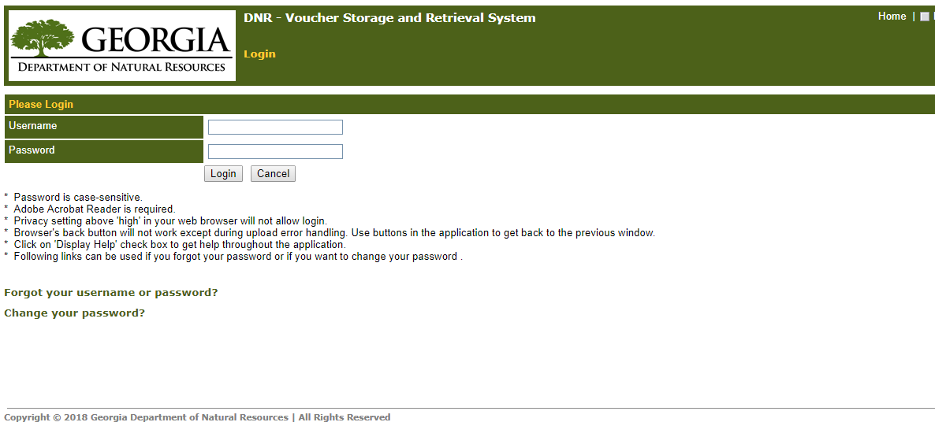

Forgot username or password:

‘Forgot your username or password?’ link can be used to retrieve your password through email (incase if you forgot your password). Enter your username and then click ‘OK’ button. Your new password will be emailed to the email address associated with your account. If you do not know your username, please contact the administrator.
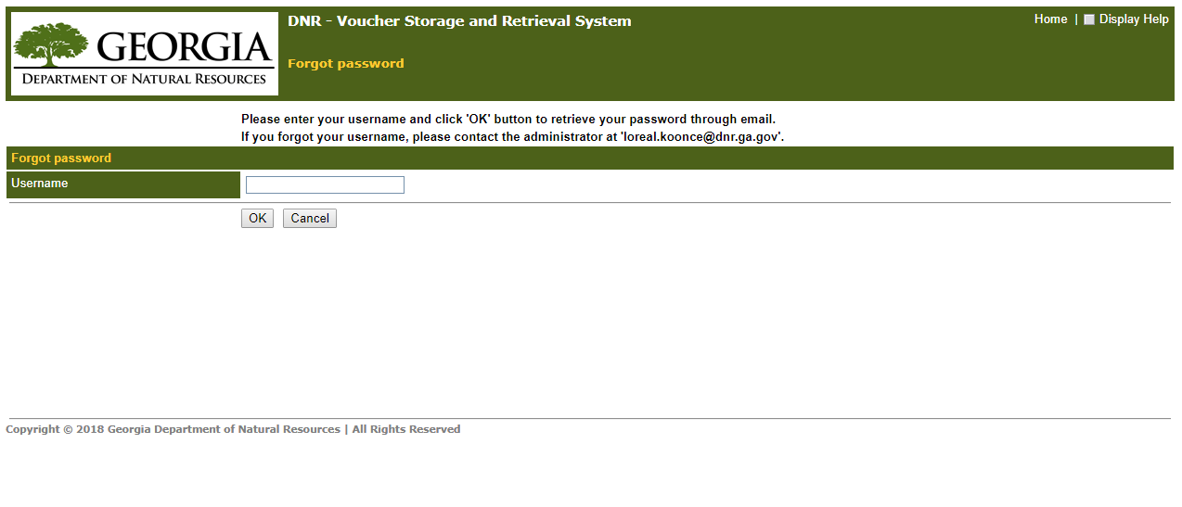

Change your password:

‘Change your password?’ link can be used to change your password.
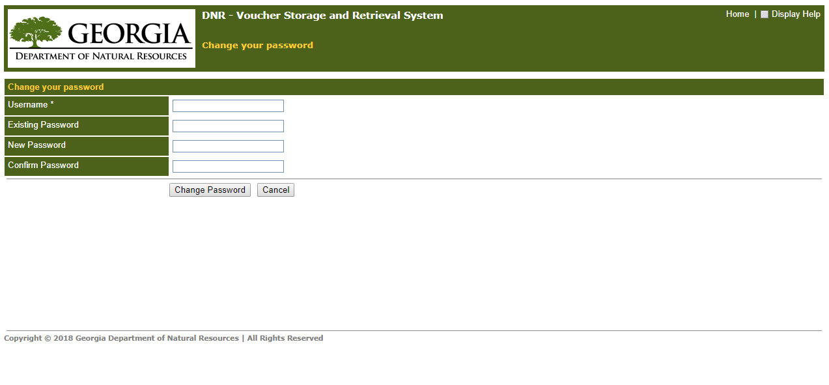
Enter all the required information and then click on ‘Change Password’ button to change your password. Click on ‘Cancel’ button to go back to the login screen.

Display Help:
‘Display Help’ check box on the top right hand corner of any window can be used to get help throughout the application (white text under DNR logo). If no help is available in the system, this will default to the contact person’s information.
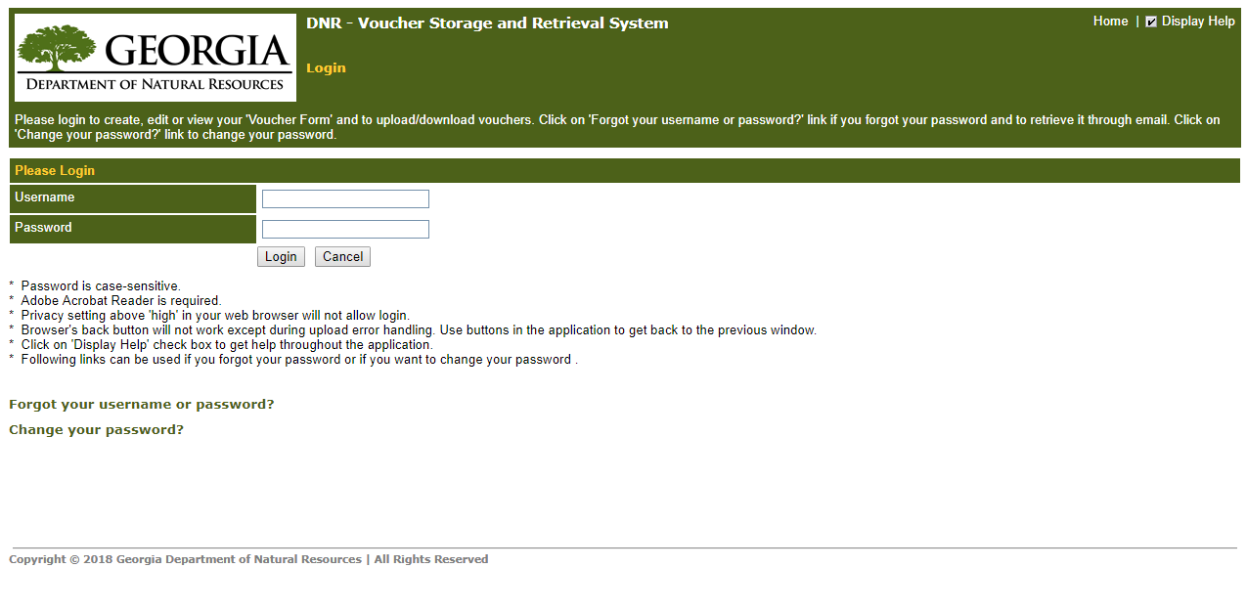

HELPFUL HINT:
You can always return to the main screen by Clicking on Home in the upper righthand corner of the screen OR by Clicking on the DNR logo in the upper lefthand corner of the screen.

NEW- June 2020
Once logged in to this website, you will need to choose which application you need: VSRS is the Voucher Storage and Retrieval System which you will access for processing payments. JSRS is Journal Storage System.
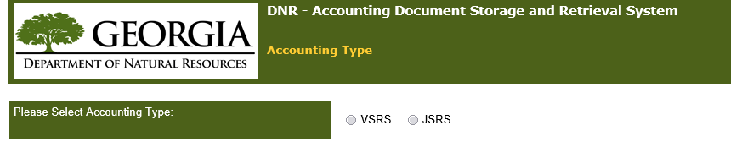

Once you select VSRS, the following main menu will be displayed. {Links in the Main Menu are visible and hidden based on the individual rights to this web application}.

Main Menu:

From this Main Menu, Field locations can:
- Create a new voucher form including W9 submissions, voucher payments, and purchase order payments
- Manage/review forms they have created.
- Review Returned Voucher forms by AP, fix any issues, and resubmit to AP
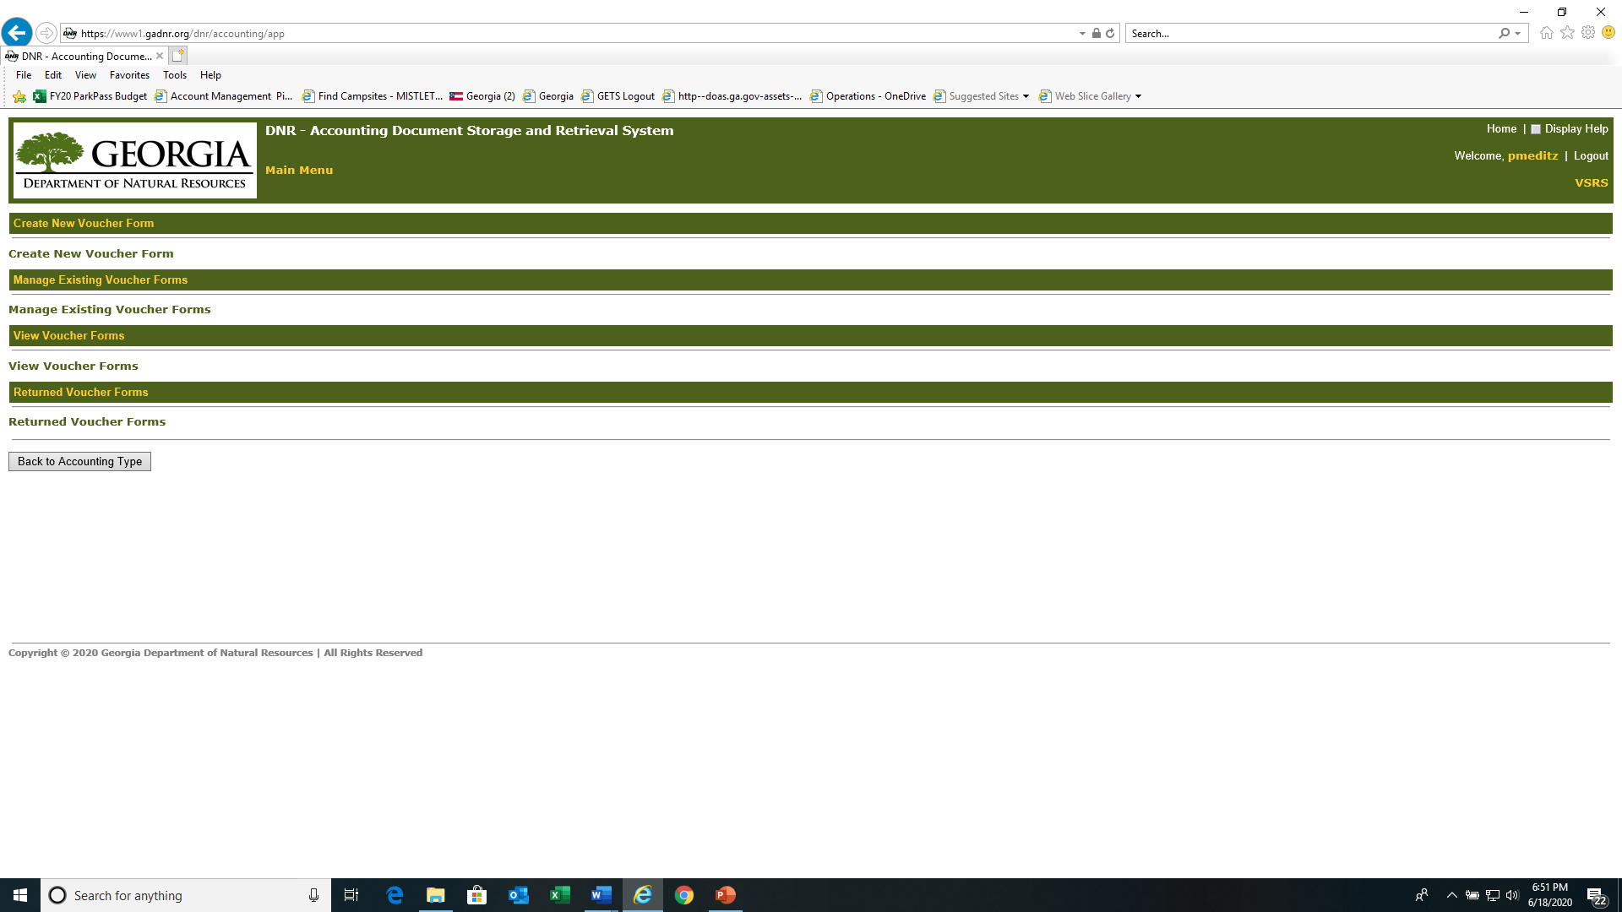

Create New Voucher Form:

From the main screen, click on Create New Voucher Form

There are multiple fields, all of which assist to route your request to the correct AP staff member.
- Each Agency is loaded under the Department number. Click on the downward arrow next to UNDEFINED and select 46204xxxx Parks.
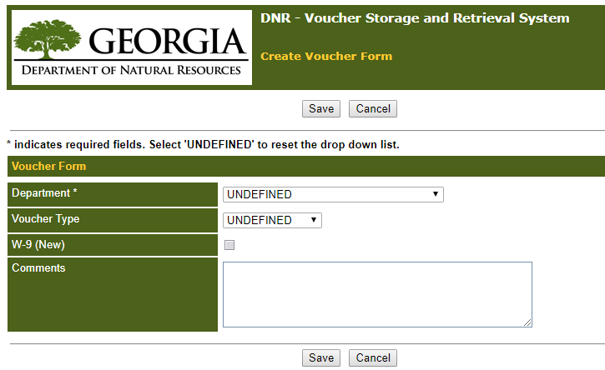

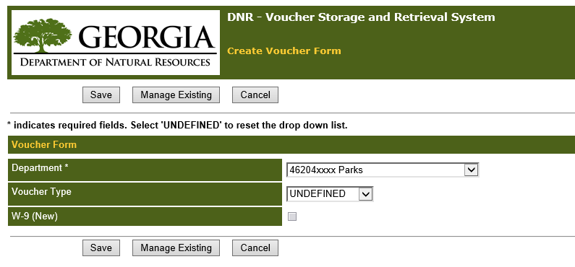

W9’s/ Vendor Management ONLY
IF you are ONLY uploading W9/vendor information, then at this stage you can just check the box next to W-9 (NEW) and click on Save to upload your file.
NOTES: You can only upload 1(one) file, so the scan should include all documents applicable such as W9, Vendor Management Form, Voided Check for new vendor ACH, etc. W9 must be signed {no auto signature} and must be recently dated {AP will not accept one dated a year+ earlier}. {Skip to SAVE-Uploading Files}

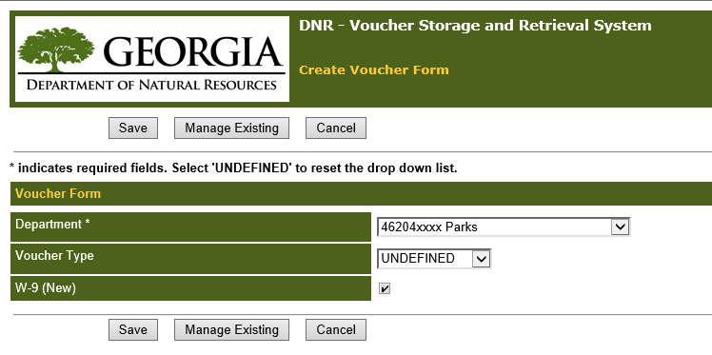

Voucher Payments
- Voucher Type will either be Regular {voucher} or Purchase Order. Click on the downward arrow next to UNDEFINED and select Regular. A new line will form so that you can further define what type of voucher, IE, Regular voucher, Resale, Operating Account, Travel, etc. Select the appropriate type.
Then Click on Save. {Skip to SAVE-Uploading Files}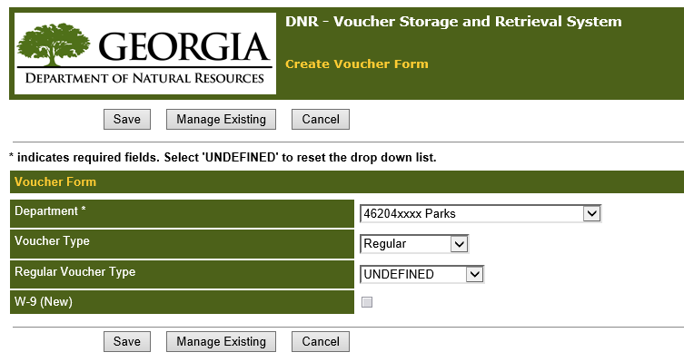

Purchase Order Payments
- Once you select Voucher Type = Purchase Order, a new line will form so you can further define what type of PO, IE, Full or Partial Payment. Select appropriate field for PO type. Then Click on Save.

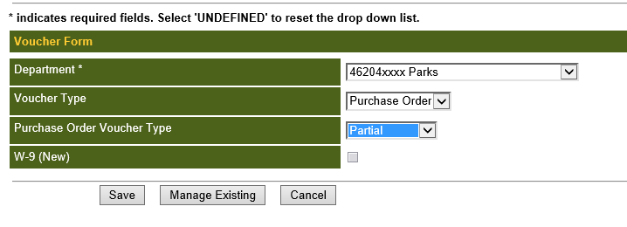

SAVE- Uploading Files
Once you select Save, this screen will allow you to Browse, Select and Upload the appropriate file.
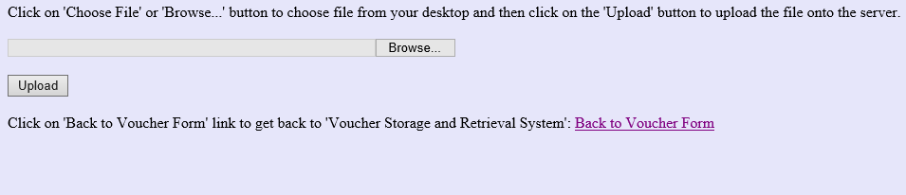

Once you Upload, the following message appears so you know you have successfully loaded your file.
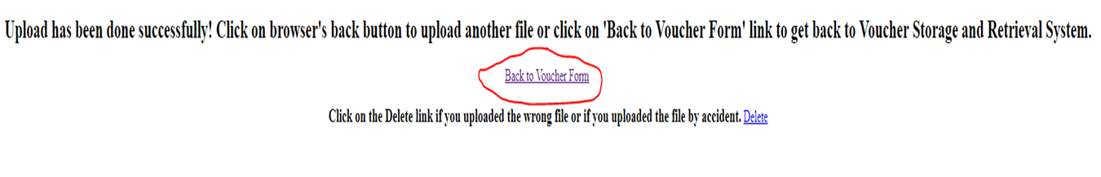

You can click on Back to Voucher Form to return to the previous Create a Voucher screen, which now includes the Form ID number assigned to your transaction. Record this number on your document or you can click on
Print Voucher Form button for a hardcopy of the transaction.

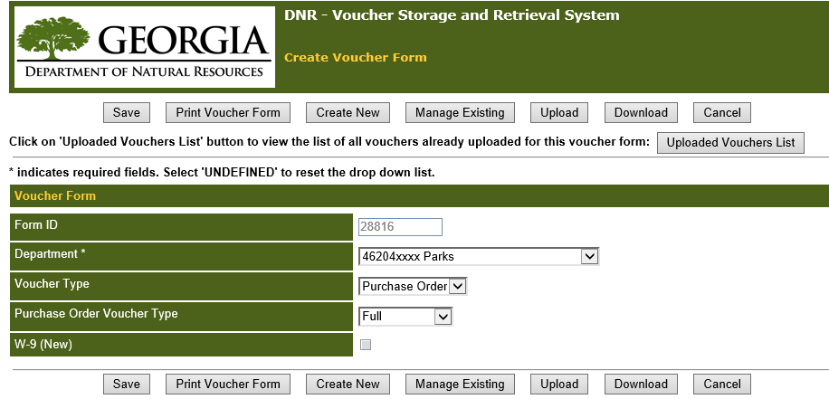
Print Voucher Form .
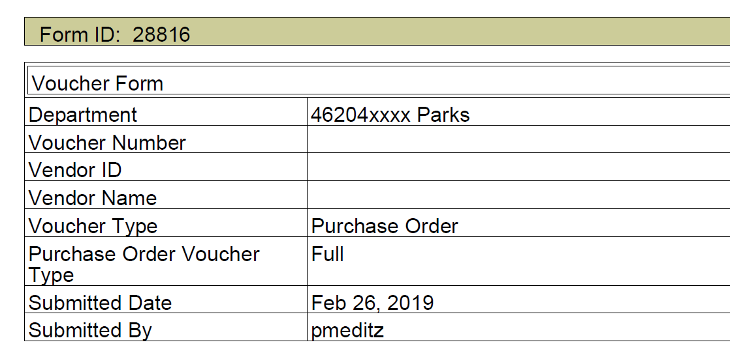
Close Adobe and Click on Back to Voucher Form

IF you have another transaction, simply Click on Create New button at the top or bottom to clear all fields and begin a new voucher form. Repeat steps above.

Reminders
- AP only needs one copy of documents scanned, make sure stamped certified copy of original on invoice(s) and sign.

- One upload at a time when creating new voucher, so the single scan file should include all necessary documents to process payment. No zip files can be uploaded!!!!

- Make sure all Purchase orders and vouchers have approval signatures… {EDX PO’s print with a gray signature box—sign above the box}.

- Make sure all documents are invoices.

- On Regular Vouchers, the Prepared by and approval signature should be two different names.

- For Operating Account vouchers make sure to include CDJ with resale regular vouchers

- On Vouchers, Parks fund source and product should be the same.

- W9’s- Make sure the W9 is signed and dated {no auto signature}. Date needs to be current, in that, AP will not accept one dated year+ ago. The Vendor Management Form for ACH needs to have a signature and date in Section 2 {no auto signature} and MUST send a copy of a voided check. In lieu of voided check, vendor may send bank letterhead form with ACH information, however, this form also needs to be signed and dated to be acceptable.

Manage Existing Voucher Forms:

From the main Screen, Click on Manage Existing Voucher Forms.

Enter search criteria in any of the 3 field options and click on the ‘Search’ button. Click ‘Cancel’ to get back to the previous window. Click ‘Reset’ to reset the screen.
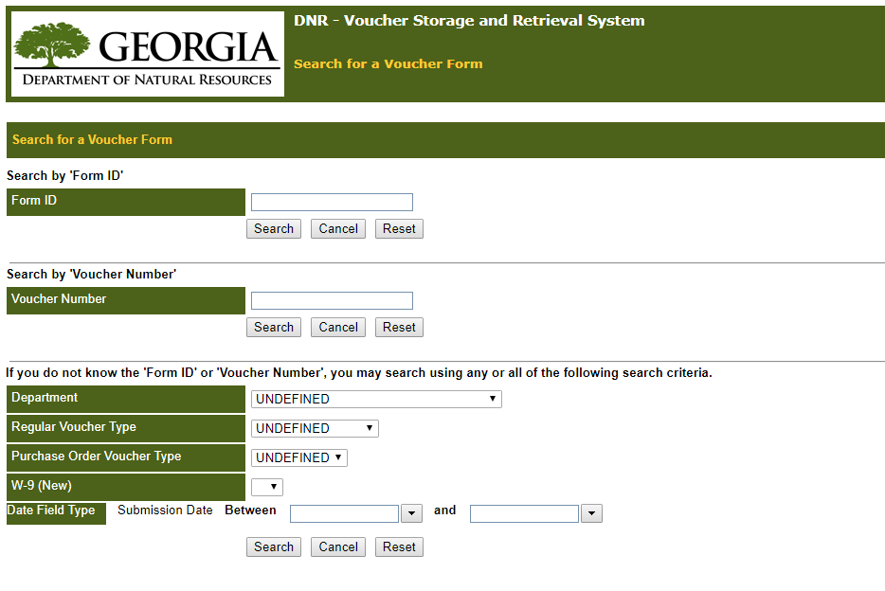

Most common searches will be either by a specific Form ID number or searching for all transactions within a given time range.

To search for a list of your transactions, at minimum you will need to define Department and Date Range. See Search Results Screen image below.
When a Form ID is processed, the PSoft Voucher number and the Modified Date and By fields will be completed.

Search Results Screen:
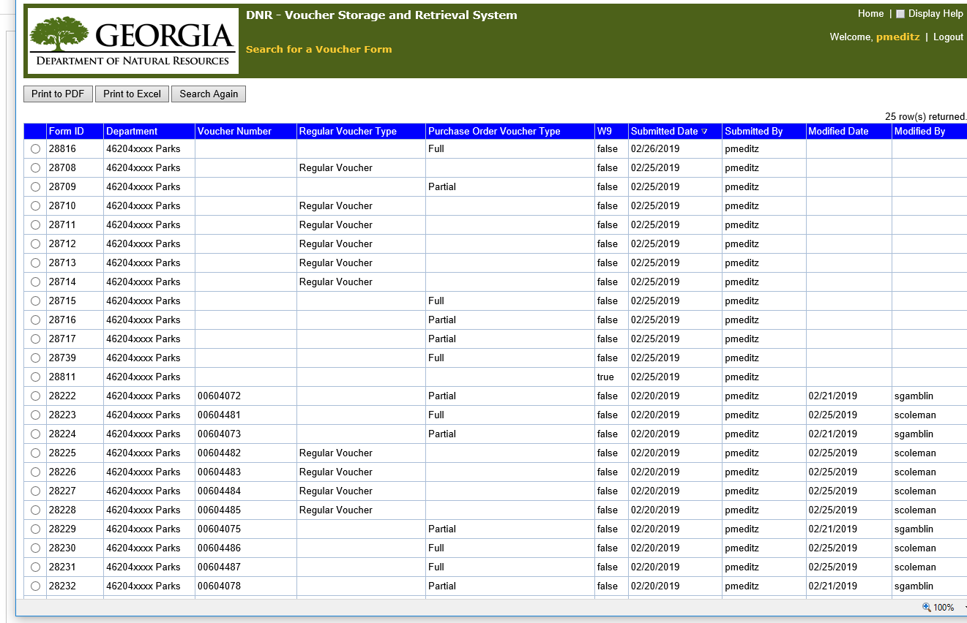

You can Print this to a PDF or Print to Excel.

Click ‘Search Again’ to get back to the search criteria screen and to search again with different search criteria.

Returned Voucher Forms
From the main Screen, Click on Returned Voucher Forms.

The list will include any of your vouchers that AP has Returned. Note: Users will receive an email notification as well.

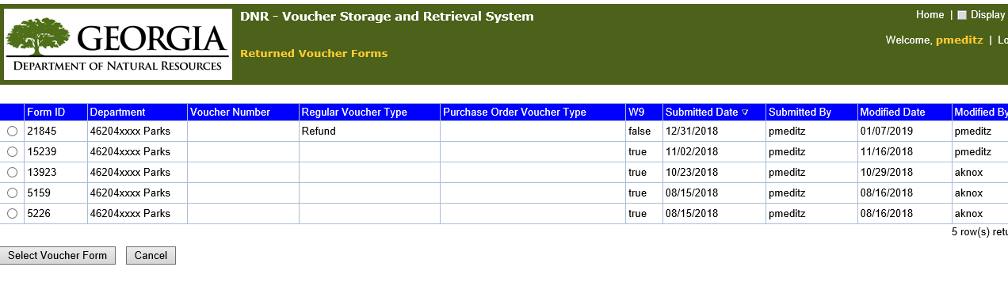
Click on the circle in front of the Form ID in order to see all the details about this transaction, fix any issues, and resubmit to AP.

View the Comments Section for the reason for the return and how to correct this issue. This Form ID has an issue with the forms that were uploaded.
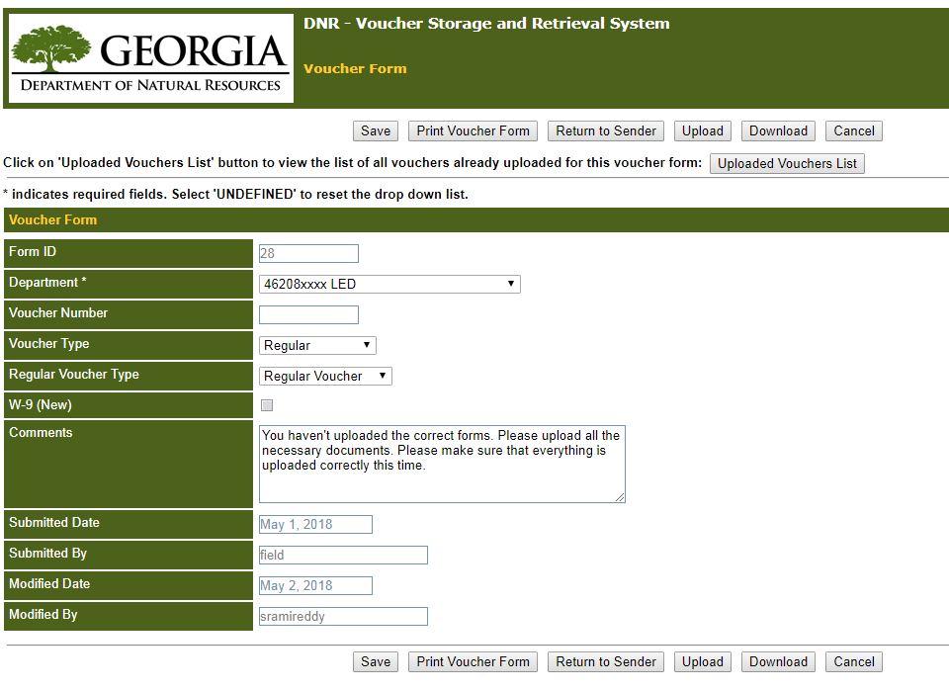

To view the forms that were uploaded on this Form ID, Click on ‘Uploaded Vouchers List’ to view the list of vouchers already uploaded to this form. The following window will be displayed. Click ‘Back to Voucher Form’ button to get back to the voucher form.
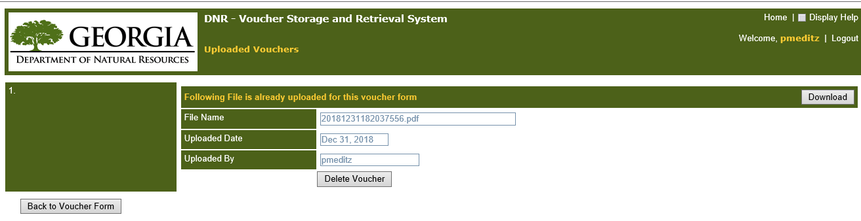
You can click on Download to view the file attached. ONLY click on Delete Voucher if there is something is wrong with the uploaded voucher. If you need to Delete Voucher, then go Back to Voucher Form and Upload correct file, following same uploading steps when creating a new voucher. Click on Back to Voucher Form after uploading.
You are almost done. In the Comments Section, Add spaces above AP’s comments and add in your own---I have uploaded the Correct forms.
Final Step is to click on Return to Sender .

View Voucher Forms

This function allows anyone to view documents submitted into the Voucher System. However, this is view only mode. Search criteria function the same as Manage Existing Voucher but once you select a specific Form ID, action buttons are limited.

